Generations
Adapted from http://johnthomsonchina.wordpress.com/2013/02/16/generations/February 16, 2013
_______________________________________________________________________________________
A study of generations in China focused on the differences between elderly, middle-aged and young Chinese people in their upbringing and attitudes towards money, education and other cultural aspects of life in China. To help us explain the differences we created three personas that are all members of the same family:

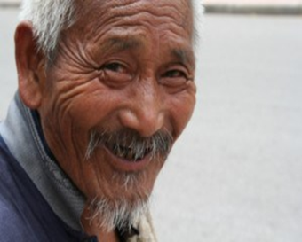 | Li Wu grew up during the early years of the communism era and lived through the suffering of the Cultural Revolution. As a result he’s a lot more conservative and holds traditional Chinese values.
Li Wang grew up after the introduction of the one child policy. His family doted on him and gave him the best opportunity possible. He’s managed to make good of his life but it has always been a struggle trying to keep up with a rapidly changing economy. |  | 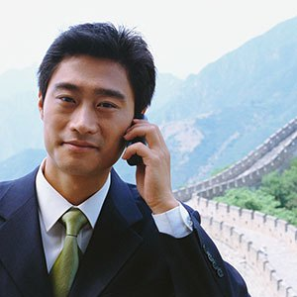
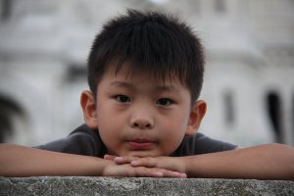 | Li Pan grew up knowing only a very prosperous China. He has a lot of national pride seeing his homeland successfully host the 2008 Olympic games. He has also been heavily doted on by his family but is less influenced by traditional Chinese ideas and more by Western culture.

Over the years, there has been a lot of dramatic change in China to a much more modern way of life. The launch of Open Door Policy in 1980 caused huge amounts of information to flood in that brought about change, although traditional values are still the mainstream. With this change came a much better quality of life – the living standard of Li Pan’s generation is much higher than his parents or grandparents. Urbanization brought people into the city – a new environment and different social rules. We have been brought up in a world of choice and diversification that my parents never thought or even heard of. Now, people are more tolerant and find it easier to adopt new and unusual things. The Chinese were poor in the last generation so they want to give their kids the best life possible.

Family  Li Wang’s marriage was arranged for him when he finished his education. This was quite common in China. Li Wang’s grandmother met her grandfather through an arranged marriage. Parents often wanted this for their children as it meant that they would be more responsible and settle into their role as providers. | 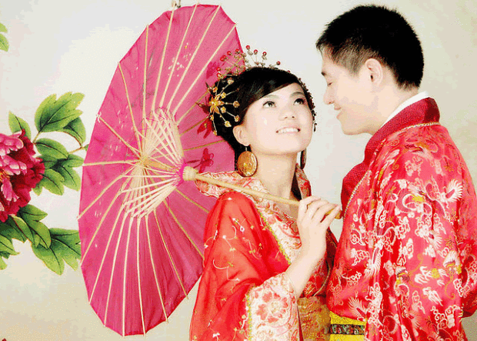
Li Wang and his wife are happy in their marriage and they hope Li Pan will do the same. Parents don’t want their children to fall in love too early or it will distract them. They should marry when they starts working so that they have responsibility. They believe that if a man wants a girl from good family to marry him he has to show he is secure by having a good apartment and a nice car.

Money
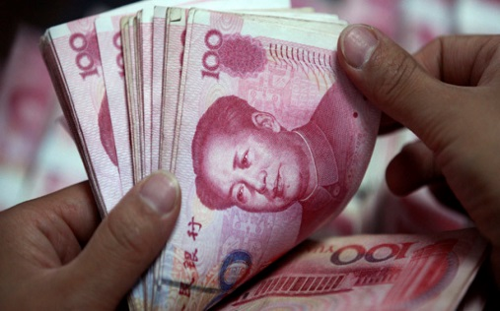 | Li Wu has a very different approach to money to his son or grandson. Many people of his generation talk about the hardship endured by their ancestors. People of Li Wu’s generation worried about whether they would have enough food and clothes to survive. Starving was a threat for many of them. They are still frugal because of their experience and will tell me stories when their children or grandchildren waste things.
Although there is still a lot of poverty in rural China there has been positive changes in the cities. More and more people are entering the middle class and making enough money to splash out, and the government encourages this consumerism. Parents are more than happy to comply and dote heavily on their children. Some feel that children are over spoiled now because the parents don’t want them to suffer like they did. Li Wang is the main money earner of the family. Some men still feel a sense of duty to earn money for the entire family.

It is not uncommon these days for women to work however it is more difficult for them to find a job, as when they were growing up, education priority was given to the males.

Education  When Li Wu was a boy he never had an education. This was down to the fact that his family simply did not have enough money. Li Wang’s mother is illiterate. At the time, the priority was for her to stay at home and work on the farm. Some families did manage to save enough money to send a child to school and priority was always given to the sons. Some people of Li Wang’s generation had enough education from school but started working at 20 so they had to leave early. More and more people like Li Wang were | 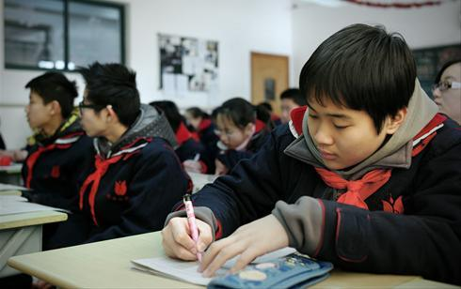
able to get a decent job in the city thanks to their schooling and earn enough money to bring their families out of poverty but it wasn’t always easy. Li Wang’s generation struggled to get the skills needed to get a job even with an education because China changed so rapidly.
Now Li Pan has been going to school since he was 5 years old. He has very good English and is much more technologically advanced than his parents. There is a lot of pressure on children to do well since they are an only child and competition is fierce. Parents send their children to after school classes and some days they don’t get home until late. Even on weekends, they are busy with schoolwork. These days having an education does not guarantee you the best possible life. Li Pan needs to prove he is talented.

Food

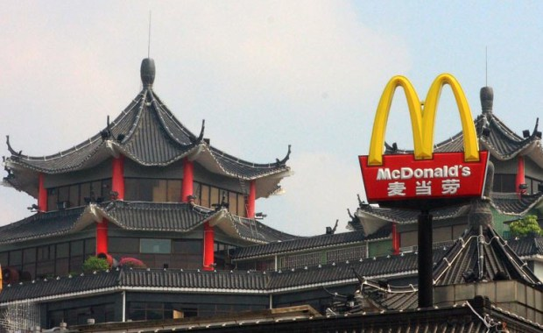 | In rural China, many people are self-sufficient in growing their own food. Older generations had farms where she grew fruit and vegetables. They were able to save money when buying food at the market. This is how Li Wu got by before moving to the city, but even now, he still prefers to buy local fresh produce for making traditional Chinese meals as opposed to Li Wang’s new found western tastes. Wealthier people now seem to be more into western culture and food. It is not uncommon for Li Wang to grab a burger from McDonalds on his lunch break when he goes out with his co-workers.
Li Pan on the other hand is often fed by his grandparents and has quite a healthy diet of meat, rice and vegetables. He still thinks it’s a treat though when his Dad takes him out for Western food.

